

DFP40203 PYTHON PROGRAMMING

LABORATORY EXERCISE
TOPIC 4.2 UNDERSTAND EXCEPTION

- Write a program that asks the user to enter two numbers and divides the first number by the second number. Handle the ZeroDivisionError exception and print an appropriate message to the user.
Coding
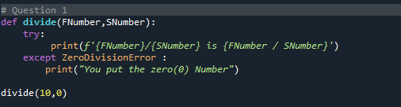
Output

- Write a program that prompts the user to enter a filename. If the file exists, the program should display its contents. If the file does not exist, the program should handle the FileNotFoundError exception and print an appropriate message to the user.
Coding
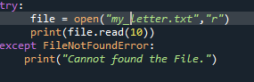
Output

Coding
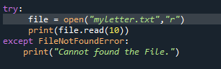
Output
- Write a function that takes a list of numbers as an argument and returns the sum of the even numbers in the list. If the list contains non-numeric values, the function should handle the ValueError exception and print an appropriate message to the user.

- Write a program that reads a text file and counts the number of occurrences of a particular word. Handle the FileNotFoundError and IOError exceptions and print an appropriate message to the user.

- Write a program that asks the user to enter a number between 1 and 10. If the number is outside of this range, the program should handle the ValueError exception and print an appropriate message to the user.

